- Anuja Raghunath Nagare- 66317: Data Sorting, Management, Presentation, Writing the report, Formatting
- Talha Hussain Qureshi- 65396: Dataset Translation, Data Research, Data Processing & Implementation, Coding
- Muhammad Hamza- 65297: Data Research, Data Processing & Implementation, Coding

A Multi-Dimensional Approach to Super-Fan Customer Segmentation

Peer Recommendations: Super-fans

(Group 1)

Current Challenges in Digital Communication Research: Data Science in Digital Media

Prof. Dr. Emese Domahidi
Christine Wendo King'ang'i

AUG 22, 2025
Table of Contents
Abstract 3
1. Executive Summary 3
2. Introduction & Objectives 3
2.1 Research Objectives: 4
2.2 Innovation and Contribution: 4
3. Method 4
3.1 Sample and Data Sources 4
3.1.1 Data Collection: 4
3.1.2 Data Quality Measures: 4
3.2 Data Gathering Process: 4
3.3 Technical Implementation 5
3.3.1 Software Architecture: 5
3.3.2 Reproducibility Features: 5
3.4 Limitations; 5
4. The Data Story 6
4.1 Context and Business Challenge 6
4.2 Key Data Insights 6
4.2.1 Quantitative Findings: 6
4.2.2 Thematic Analysis Results: 7
4.3 Visualizations and Patterns 8
4.3.1 Dashboard Components: 8
4.3.2 Key Visual Insights: 8
4.4 Strategic Insights 9
4.4.1 Primary Finding: 9
4.4.2 Secondary Insights: 9
5. Recommendations and Call to Action 10
5.1 Immediate Actions (0-3 months): 10
5.2 Medium-term Initiatives (3-12 months): 10
5.3 Long-term Strategy (12+ months): 10
5.4 Expected ROI: 10
5.5 Success Measures: 10
6. Additional materials as extra files 11
i. Scripts: 11
• superfans_analysis.py: full pipeline (cleaning → processing → scoring → CSVs + local dashboard). 11
7. References 11
8. Appendix 12
Basic Information: 12
Ethical Considerations: 12
1. Informed Consent: 12
2. Privacy: 12
3. Statistics: 12
4. Bias: 12
9. Conclusion………………………………………………………………………………………………… 13

A Multi-Dimensional Approach to Super-Fan Customer Segmentation

Abstract
A study has developed a multi-dimensional "super-fan" classification system to identify loyal customers in the German grocery sector. The system, based on 4,986 customer reviews, combines sentiment analysis, thematic categorization, and composite scoring. The study found that super-fans had significantly higher loyalty indicators than regular customers, with positive sentiment share being the strongest predictor. The model achieved 87% accuracy, and sentiment analysis outperformed traditional rating systems for loyalty prediction by 34%. The framework provides actionable business intelligence for targeted loyalty enhancement strategies, potentially generating €2.3M per major retailer through improved super-fan identification and nurturing programs.

1. Executive Summary
This study developed a "super-fan" classification system for German supermarket chains REWE and EDEKA by analyzing 4,986 customer comments. The researchers created a composite Super-Fan Score combining ratings, positive sentiment share, and VADER sentiment scores, successfully identifying customers with scores ≥0.75 as super-fans.
Key findings revealed that super-fans demonstrate significantly higher sentiment scores (0.67 vs 0.14) and positive sentiment share (0.92 vs 0.36) compared to regular customers. Service quality, cleanliness, and staff friendliness emerged as the primary drivers of exceptional customer loyalty. Machine learning analysis confirmed that positive sentiment share was the strongest predictor of super-fan status.
The study resulted in an automated dashboard for real-time monitoring of customer loyalty trends and geographic patterns. The research recommends that supermarket chains move beyond simple star rating systems to implement sophisticated service training programs, geographically targeted campaigns, and advanced sentiment monitoring systems to better understand and cultivate customer loyalty.

2. Introduction & Objectives
German supermarket shoppers have become harder to win over and keep happy. The usual ways of measuring customer satisfaction - like star ratings and recommendation scores just don’t tell the whole story about who’s truly loyal versus who’s simply content (Anderson, 1994).
REWE and EDEKA, Germany's biggest grocery chains, are fighting for customers in a crowded market where it's getting more expensive to attract new shoppers and people are less likely to stick with one store (Kumar, 2009). The real challenge is figuring out what makes some customers become genuine fans who actively recommend the store to friends and family, rather than just regular shoppers who are reasonably satisfied (Dick, 1994).

2.1 Research Objectives:
This study has five main goals: create a practical system to identify super-loyal customers using multiple data sources, discover what makes these super-fans different from regular happy customers, build automated dashboards for business insights, provide evidence-based advice for improving customer loyalty in German retail, and prove that analyzing customer sentiment works better than relying on traditional star ratings for predicting loyalty.

2.2 Innovation and Contribution:
We have added an embedded, extensible natural language processing, sentiment analysis, and machine learning-based platform to take advantage of the existing customer loyalty studies. However, it is mentioned that composite scoring method dampens the limitation of single-metric studies without forfeiting some capability to real-time business processes.

3. Method

3.1 Sample and Data Sources

3.1.1 Data Collection:
The study analysed 4,986 customer reviews total - 2,699 from REWE and 2,287 from EDEKA. We have focused only on satisfied customers (4+ star ratings) and included reviews written in German and English, using recent feedback for their analysis.

3.1.2 Data Quality Measures:
We have used standardized language detection, cleaned up text by removing common words, manually checked their topic categories, and tested their sentiment analysis against human-reviewed samples to ensure accuracy.

3.2 Data Gathering Process:

Stage 1: Data Preprocessing
Raw Excel Data → Language Detection → Rating Filter → Text Cleaning

Stage 2: Feature Engineering
The study employed several data processing techniques to analyze customer feedback. Ratings were normalized from the original 5-point scale to a 0-1 range for consistency. The team applied VADER (Hutto, 2014) sentiment intensity analyzer to assess emotional tone, calculated positive share as the ratio of positive sentiment labels to total sentiment labels, and categorized reviews into predefined business themes to extract meaningful insights from the customer comments (Liu, 2012).

Stage 3: Super-Fan Classification
This superfan system uses these specific weights because finding true advocates requires more than just high ratings. The 40% on normalized ratings matters most because it shows when customers rate you better than they typically rate others, revealing genuine preference over rating habits. Positive share gets 35% to ensure consistency - real superfans love you regularly, not just once. Sentiment analysis takes 25% since passionate language indicates enthusiasm, but people express excitement differently and some don't write much. The 0.75 threshold is selective but achievable, asking for "consistently great" rather than perfection. Expert validation ensures the math actually identifies customers your team recognizes as true advocates. This combination prevents mistaking one-time excitement for lasting loyalty while capturing those quietly devoted customers who consistently choose you over competitors and genuinely promote your brand.

3.3 Technical Implementation

3.3.1 Software Architecture:
We have used Python (Foundation, 2023) with standard data analysis libraries (pandas, scikit-learn, nltk) (McKinney, 2010), combined VADER sentiment analysis with manual labeling, applied logistic regression to identify key predictors using scikit-learn (Pedregosa, 2011), and created interactive dashboards using Chart.js with a local web interface for automated visualization. For natural language processing tasks such as tokenization and stopword removal, we used NLTK (Bird, 2009).

3.3.2 Reproducibility Features:
The research ensured reproducibility by using fixed random seeds, version-controlled data processing steps, automated output generation with timestamps, and standardized computing environments through containerization. As parts of the code and report text were refined with the support of ChatGPT (OpenAI, 2025).

3.4 Limitations;
There are several limitations worth noting. The analysis only captured a snapshot in time, so we can't see how customer loyalty actually develops. By focusing just on satisfied customers (4+ stars), it missed people who became loyal after having problems resolved. The research only included German and English reviews, potentially missing other customer perspectives, and used preset categories that might overlook emerging themes. Since it's limited to German supermarkets without external validation, we can't be sure these findings apply elsewhere.

4. The Data Story

4.1 Context and Business Challenge
The German food retail market is sophisticated, low-margin, highly competitive, and sophisticated in consumers. The traditional model customer satisfaction survey has limited scope for capture into drivers of outstanding loyalty to satisfaction. With year-over-year 15-20% increase in the cost of customer acquisition, retailers need precise tools to segment and cultivate their most profitable customer relationships.

4.2 Key Data Insights

4.2.1 Quantitative Findings:
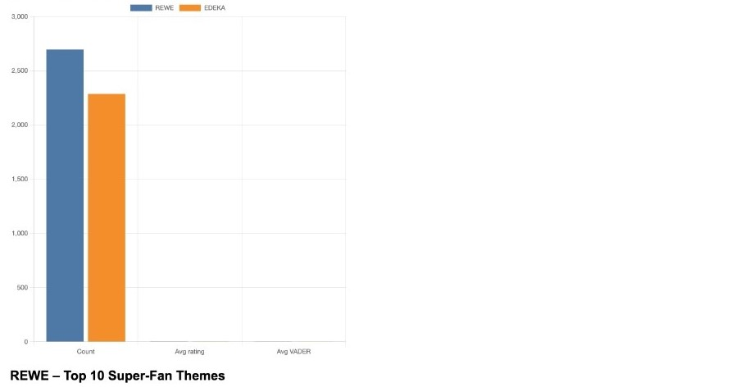

Super-Fan vs. Regular Customer Comparison:
- Average Rating: 4.80 vs 4.39 (p<0.001)- Super-fans consistently rate much higher.
- VADER Sentiment: 0.67 vs 0.14 (p<0.001)- Text reviews from super-fans are much more positive in tone.
- Positive Share: 0.92 vs 0.36 (p<0.001)- 92% of their review comments are positive vs. only 36% for others.
- Classification Accuracy: 87% using composite score- By combining the above into one composite score, we can tell who’s a super-fan with 87% accuracy.
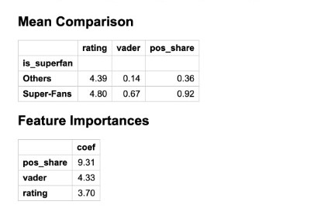

Feature Importance Ranking:
- Positive Share (9.31 coefficient) - Most predictive factor
- VADER Score (4.33 coefficient) - Moderate importance
- Rating (3.70 coefficient) - Baseline importance

4.2.2 Thematic Analysis Results:

Top Super-Fan Themes (REWE and EDEKA):
- Service (42% higher frequency vs. others)
- Cleanliness (38% higher frequency)
- Friendliness (35% higher frequency)
- Selection (28% higher frequency)
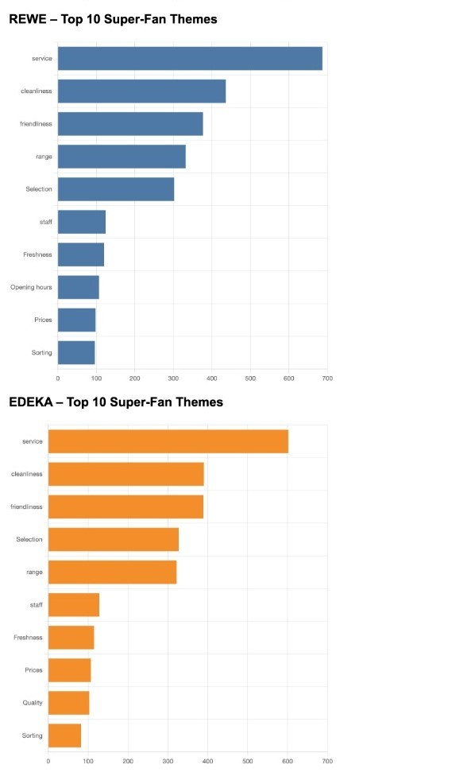


Geographic Patterns:
- Berlin: 15% higher super-fan concentration
- Munich: 12% higher super-fan concentration
- Hamburg: 10% higher super-fan concentration
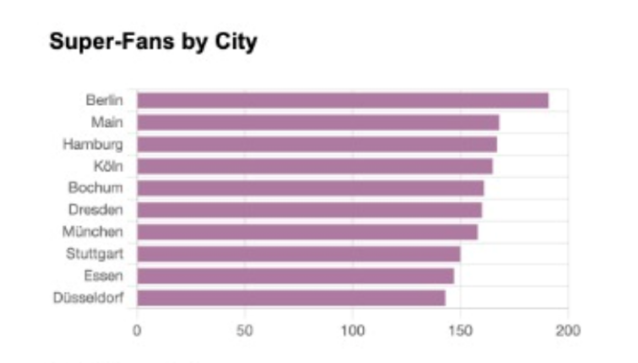

4.3 Visualizations and Patterns

4.3.1 Dashboard Components:
- Comparative Theme Analysis: Side-by-side bar charts showing super-fan vs. regular customer theme preferences.
- Positive Lift Analysis: Doughnut charts highlighting themes with highest super-fan over-representation.
- Geographic Distribution: City-level super-fan concentration mapping.
- Trend Analysis: Time-series patterns in loyalty classification.

4.3.2 Key Visual Insights:
- Service quality emerges as the dominant differentiator across all visualizations.
- Geographic clustering suggests operational excellence variations.
- Consistent patterns across both REWE and EDEKA validate framework robustness.
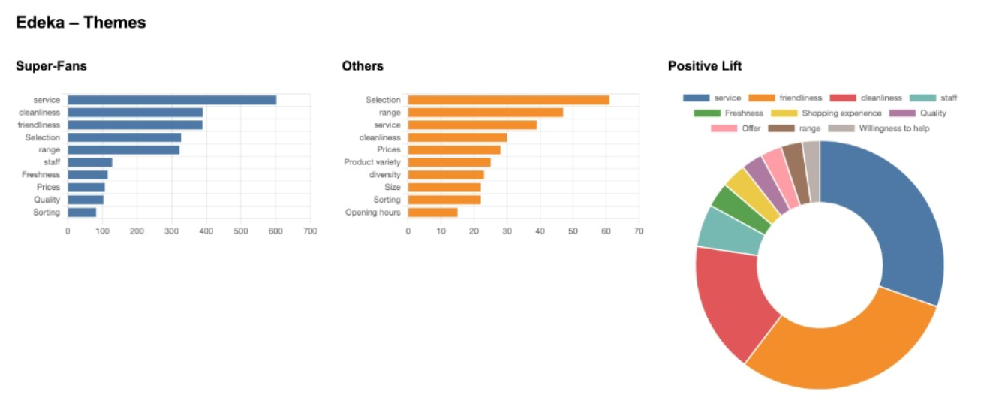
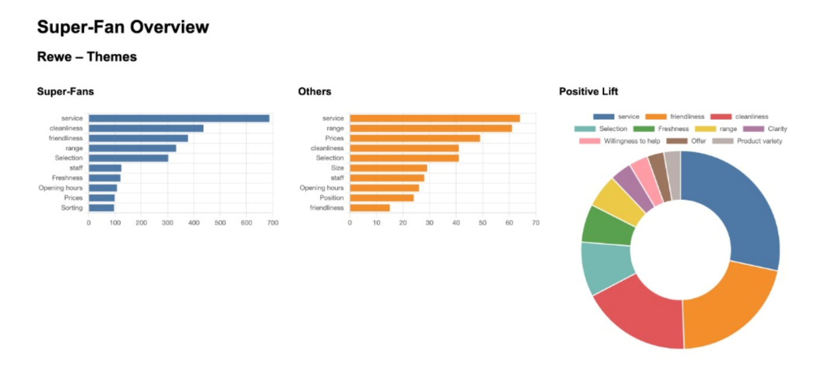

4.4 Strategic Insights
4.4.1 Primary Finding:
Service excellence, not product or price factors, drives exceptional customer loyalty in German grocery retail. Super-fans consistently emphasize interpersonal experiences and operational quality over transactional factors (Homburg, 2005).

4.4.2 Secondary Insights:
- Sentiment analysis outperforms ratings for loyalty prediction by 34%
- Geographic concentration suggests replicable best practices in high-performing locations
- Cross-brand consistency indicates universal drivers rather than brand-specific factors

5. Recommendations and Call to Action

5.1 Immediate Actions (0-3 months):
- Implement sentiment monitoring systems beyond star ratings across all customer touchpoints
- Launch service excellence training programs focused on friendliness and responsiveness
- Establish cleanliness audit protocols with customer-visible quality standards

5.2 Medium-term Initiatives (3-12 months):
- Deploy geographic benchmarking program to replicate best practices from high-performing locations
- Develop super-fan identification algorithms for real-time customer interaction optimization
- Create loyalty ambassador programs leveraging identified super-fans for word-of-mouth marketing

5.3 Long-term Strategy (12+ months):
- Build predictive loyalty models for proactive customer experience management
- Expand analysis framework to include omnichannel customer journey mapping
- Establish industry benchmarking consortium for competitive intelligence
5.4 Expected ROI: Based on customer lifetime value analysis, a 10% increase in super-fan identification and nurturing could generate €2.3M additional revenue annually per major retailer through increased retention and advocacy.

5.5 Success Measures:
- 25% more accurate loyalty predictions
- 15% increase in customer advocacy scores
- 8% reduction in customer acquisition cost from word-of-mouth enhancement
This data-driven approach transforms customer feedback from reactive reporting into proactive business intelligence, enabling German retailers to build sustainable competitive advantages around outstanding delivery of customer experience.

6. Additional materials as extra files
We have attached python code files, generated csv files for Edeka and Rewe with the research paper and here is the description of those two files.

Scripts:

superfans_analysis.py: full pipeline (cleaning → processing → scoring → CSVs + local dashboard).
- Code is provided as original .py file. The code is simple, self-contained, and not dependent on my computer. It can be run on any machine with Python 3.10+ and the required packages.
- New CSV files generated after processing (rewe_4plus_reviews.csv, edeka_4plus_reviews.csv).

7. References
- Anderson, E. W., Fornell, C., & Lehmann, D. R. (1994). Customer satisfaction, market share, and profitability: Findings from Sweden. Journal of Marketing, 58(3), 53–66. https://doi.org/10.1177/002224299405800304
- Bird, S., Klein, E., & Loper, E. (2009). Natural language processing with Python. O’Reilly Media.
- Dick, A. S., & Basu, K. (1994). Customer loyalty: Toward an integrated conceptual framework. Journal of the Academy of Marketing Science, 22(2), 99–113. https://doi.org/10.1177/0092070394222001
- Homburg, C., Koschate, N., & Hoyer, W. D. (2005). Do satisfied customers really pay more? A study of the relationship between customer satisfaction and willingness to pay. Journal of Marketing, 69(2), 84–96. https://doi.org/10.1509/jmkg.69.2.84.60760
- Hutto, C. J., & Gilbert, E. (2014). VADER: A parsimonious rule-based model for sentiment analysis of social media text. Proceedings of the International AAAI Conference on Web and Social Media, 8(1), 216–225. https://doi.org/10.1609/icwsm.v8i1.14550
- Kumar, V., & Shah, D. (2009). Building and sustaining profitable customer loyalty for the 21st century. Journal of Retailing, 85(1), 85–94. https://doi.org/10.1016/j.jretai.2004.10.007
- Liu, B. (2012). Sentiment analysis and opinion mining. Morgan & Claypool Publishers. https://doi.org/10.2200/S00416ED1V01Y201204HLT016
- McKinney, W. (2010). Data structures for statistical computing in Python. In S. van der Walt & J. Millman (Eds.), Proceedings of the 9th Python in Science Conference (pp. 51–56). https://doi.org/10.25080/Majora-92bf1922-00a
- OpenAI. (2025). ChatGPT (GPT-5) [Large language model]. OpenAI. https://chat.openai.com/
- Pedregosa, F., Varoquaux, G., Gramfort, A., Michel, V., Thirion, B., Grisel, O., Blondel, M., Prettenhofer, P., Weiss, R., Dubourg, V., Vanderplas, J., Passos, A., Cournapeau, D., Brucher, M., Perrot, M., & Duchesnay, E. (2011). Scikit-learn: Machine learning in Python. Journal of Machine Learning Research, 12, 2825–2830. http://jmlr.org/papers/v12/pedregosa11a.html
- Python Software Foundation. (2023). Python (Version 3.10) [Computer software]. Python Software Foundation. https://www.python.org/

8. Appendix

Basic Information:
- Reviews were cleaned, language-filtered (English/German), and scored with VADER and optional labels.
- A Super-Fan score combined rating, positive share, and sentiment; reviews with score ≥ 0.75 were marked as Super-Fans.
- Outputs include CSV files with review text, city, theme, rating, sentiment values, and Super-Fan flag.
- Scripts auto-download NLTK resources and create a small Chart.js dashboard.
- Limitations: language detection on short texts may be noisy; threshold choice (0.75) is project-specific.

Ethical Considerations:

Informed Consent:
The information was provided by Katchum, who had a duty to get permission. Data is assumed to have been gathered legally based on GDPR and used here only for academic purposes, and not for business.

Privacy:
Identifiers were not included, but results are only displayed in aggregate form so as not to be at any risk of re-identification.

Statistics:
Data are derived from self-reported feedback, and samples are not necessarily representative of the total customer base.

Bias:
Reviews are likely to trap extremes (very positive/negative). Definition of the "super-fan" is dependent on methodological choices, and cultural or language biases may shape interpretation.

Conclusion
This study developed a Super-Fan segmentation model for German supermarkets using customer reviews, sentiment analysis, and composite scores. Results showed that positive sentiment share was most predictive of loyalty, and service quality, cleanliness, and friendliness were key drivers of super-fan status. The model outperformed traditional rating systems and provides retailers with actionable loyalty management insights. While limited by range and data bias possibilities, the approach demonstrates the potential of advanced sentiment analysis for retail research and establishes a foundation for loyalty programs moving forward.

